Natural Reader: Text to Speech software

How to Use the Natural Reader Software:
**User must have Google Chrome downloaded prior to downloading Natural Reader**
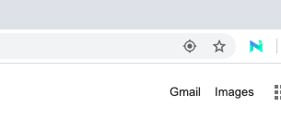
- Open Google Chrome browser, after downloading Natural Reader the icon will be located in the top right hand corner.

- To use the Natural Reader Icon, when selected the drop down icon will appear. A user may push the “play” button, and the software will begin reading what appears on the screen.
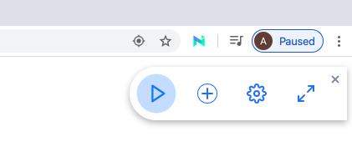

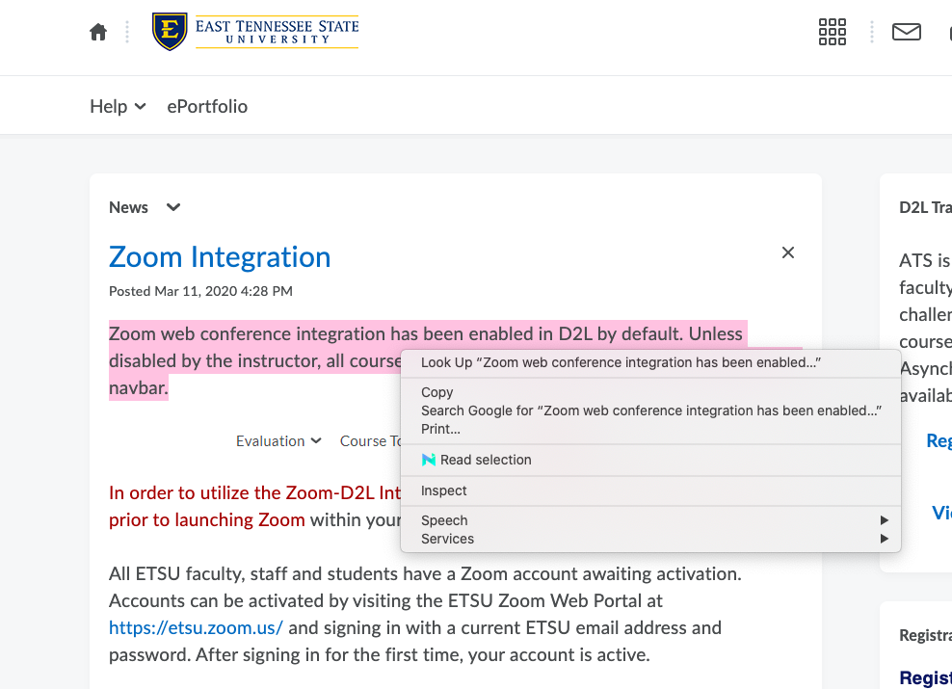
- If you wish for the program to only read a specific section from your screen. First, highlight that specific text and then right click your screen.
- After right clicking, select the “read selection” option and Natural Reader will begin reading the highlighted section on your browser.
